**Helmet and Number Plate Detection**

**for Challan Generation**

***This project report is submitted to***

**Yeshwantrao Chavan College of Engineering**

***(An Autonomous Institution Affiliated to Rashtrasant Tukdoji Maharaj Nagpur University)***

***In partial fulfilment of the requirement for the award of the degree***

***Of***

**Bachelor of Technology in Electronics and Telecommunication Engineering**

***By***

**Harsh Chouhan**

**Ishika Ukey**

**Joydeep Das**

**Piyush Langde**

***Under the guidance of***

**Prof. Sandip Desai**



**DEPARTMENT OF ELECTRONICS AND TELECOMMUNICATION ENGINEERING**

**Nagar Yuwak Shikshan Santha’s**

**YESHWANTRAO CHAVAN COLLEGE OF ENGINEERING, NAGPUR**

***(An Autonomous Institution Affiliated to Rashtrasant Tukadoji Maharaj Nagpur University, Nagpur -441110)***

**2023-2024**

**CERTIFICATE OF APPROVAL**

This is to Certify that the project report entitled **“Helmet and Number Plate Detection for Challan Generation”** has been successfully completed by **ISHIKA UKEY, HARSH CHOUHAN, JOYDEEP DAS, PIYUSH LANGDE** under the guidance of **PROF. SANDIP DESAI** in recognition to the partial fulfillment for the award of the degree of Bachelor of Technology in Electronics and Telecommunication Engineering, **Yeshwantrao Chavan College of Engineering *(An Autonomous Institution Affiliated to Rashtrasant Tukdoji Maharaj Nagpur University).***

Signature Signature Signature

**Prof. Sandip Desai Mr. Harsh Chordia Dr. M. S. Narlawar**

**(Guide) (Data Scientist /Co-Guide) (HoD, ET Dept.)**

Signature of External Examiner

Name:

Date of Examination:

**DECLARATION**

We hereby declare that

1. The work contained in this project has been done by us under the guidance of my supervisor.
2. The work has not been submitted to any other Institute for any degree or diploma.
3. We have followed the guidelines provided by the Institute in preparing the project report.
4. We have conformed to the norms and guidelines given in the Ethical Code of Conduct of the Institute.
5. Whenever we have used materials (data, theoretical analysis, figures, and text) from other sources, we have given due credit to them by citing them in the text of the report and giving their details in the references. Further, we have taken permission from the copyright owners of the sources, whenever necessary.

**Name of the Students Signature**

1. Ishika Ukey

2. Harsh Chouhan

3. Joydeep Das

4. Piyush Langde

Date: 14/12/2023

Place: Nagpur

**ACKNOWLEDGEMENTS**

We are grateful to Yeshwantrao Chavan College of Engineering, Nagpur for giving us an opportunity to develop this project with an esteemed organization. The volume of the work would not have been possible without contribution in one form or the other by few names to mention.

We take this opportunity to acknowledge the support and continuous cooperation of all the people whose help was unparalleled importance in making this project a success. We welcome this opportunity to express our heartfelt gratitude and regards to our project guide **Prof. Sandip Desai**, Department of Electronics and Telecommunication Engineering, Yeshwantrao Chavan College of Engineering, who encouraged and supported us by giving continuous guidance, which kept us motivated throughout the project.

We are thankful to our Honorable Principal **Dr. U.P. Waghe,** Yeshwantrao Chavan College of Engineering, Nagpur for the support.

We are highly grateful to **Dr.Milind Narlawar**, Head of Department, Electronics and Telecommunication Engineering, Yeshwantrao Chavan College of Engineering for providing necessary facilities during the course of the work. We are thankful to and fortunate enough to get constant encouragement, support and guidance from all the Teaching staffs of Electronics and Telecommunication Department which helped us in successfully completing our project work. Also, we would like to extend our sincere esteems to all the staffs in laboratory for their timely support.

Ishika Ukey

Harsh Chouhan

Joydeep Das

Piyush Langde

**TABLE OF CONTENTS**

|  |  |
| --- | --- |
| **Contents** | **Page No.** |
| Title Page | 1 |
| Certificate of Approval | 2 |
| Declaration | 3 |
| Acknowledgement | 4 |
| **Contents** | 5 |
| Abstract | 6 |
| **Chapter 1: Introduction** | 7-8 |
| 1.1 Overview | 7 |
| 1.2 Problem Statement | 8 |
| 1.3 Objective | 8 |
| **Chapter 2:** **Construction & Working of Model** | 9-14 |
| 2.1 Design / Working Mechanism | 9 |
| 2.2 Algorithm Used / Training | 10 |
| **Chapter 3: Details** | 15-18 |
| 3.1 Work Done | 15 |
| 3.2 Software or components used | 17 |
| 3.3 Advancement in Project | 18 |
| **Chapter 4:** **Results, Discussions and Conclusions** | 20-23 |
| 4.1 Results | 20 |
| 4.2 Model Evaluation | 22 |
| 4.3 Conclusions | 23 |
| **Chapter 5: Literature Cited** | 24 |

**ABSTRACT**

In an era marked by technological advancements, enhancing the efficiency of law enforcement processes is crucial for maintaining public safety. The project, titled "Helmet and Number Plate Detection for Challan Generation," addresses the need for an intelligent system that can automate the monitoring of traffic rules violations. By leveraging computer vision techniques, the project focuses on detecting the absence of helmets and obscured or missing number plates on vehicles.

The proposed system utilizes state-of-the-art object detection algorithms, enabling real-time analysis of video streams from surveillance cameras. Through the integration of advanced image processing and deep learning technologies, the system identifies and records instances of non-compliance with traffic regulations.

This project aims to contribute to the optimization of traffic management by automating the identification of violations related to helmet usage and proper display of vehicle number plates. The generated data can be utilized for streamlined challan (ticket) generation, allowing law enforcement agencies to efficiently address traffic rule violations..

**CHAPTER 1: INTRODUCTION**

**1.1 OVERVIEW**

Traffic rule enforcement is a critical aspect of ensuring road safety and maintaining an organized flow of vehicles. Traditionally, monitoring and penalizing traffic violations have heavily relied on manual intervention, making the process time-consuming and prone to errors. The "Helmet and Number Plate Detection for Challan Generation" project seeks to revolutionize this process by introducing an intelligent system that employs computer vision and deep learning techniques.

The primary objectives of the project include the detection of two common traffic violations: the absence of helmets on riders and the improper display or absence of vehicle number plates. The project utilizes advanced object detection algorithms, such as YOLO (You Only Look Once), to analyze video feeds from surveillance cameras in real-time.

By employing machine learning models, the system learns to recognize patterns associated with non-compliance with helmet usage and number plate display. The proposed solution integrates seamlessly with existing traffic monitoring infrastructure, providing an efficient means of identifying violators without human intervention.

The significance of this project lies in its potential to enhance the effectiveness of law enforcement, reduce manual workload, and improve overall road safety. The subsequent sections of this report will delve into the methodology, implementation details, results, and future enhancements of the "Helmet and Number Plate Detection for Challan Generation" system.

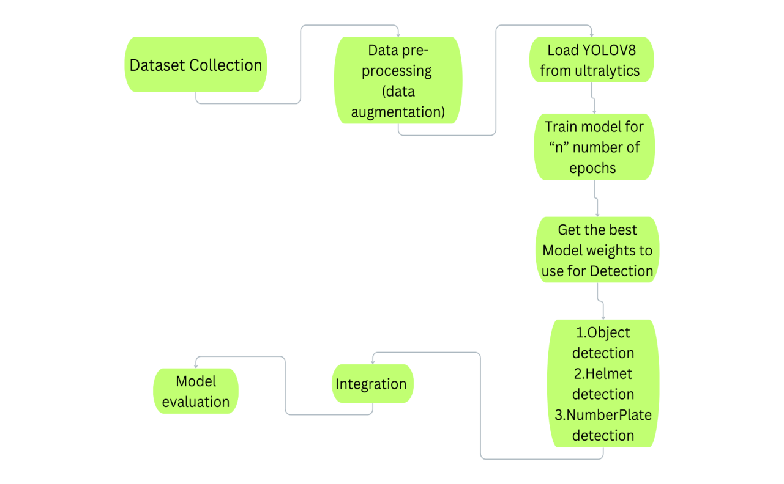

*Fig 1: Work Flow*

**1.2 PROBLEM STATEMENT**

The persistent challenges of non-compliance with helmet regulations and the prevalence of triple riding on two-wheelers in India underscore the urgent need for effective solutions to enhance road safety. The existing scenario contributes significantly to an increased risk of head injuries and accidents. Our project aims to address this critical issue by formulating an 'Intelligent Helmet Detection' system, leveraging computer vision. This system will play a pivotal role in real-time identification of riders without helmets, allowing for automated challan generation. The overarching goal is to provide a comprehensive solution that not only improves overall road safety but also streamlines enforcement measures against non-compliance with helmet regulations and triple riding on two-wheelers.

**1.3 OBJECTIVE**

The overarching objective of the project, titled "Helmet and Number Plate Detection for Challan Generation," is to leverage computer vision techniques to enhance road safety and enforce traffic regulations. The primary focus is on developing a comprehensive system capable of detecting and recognizing both helmets worn by individuals and vehicle number plates.

The project aims to implement a robust object detection system for accurately identifying instances of helmets in images or video frames. This involves ensuring precise localization and recognition of helmets on individuals, contributing to the overarching goal of promoting safety among two-wheeler riders.

In parallel, the project endeavors to create an effective algorithm for the detection and extraction of number plates from vehicles. This includes the development of techniques to accurately identify and recognize alphanumeric characters on the detected number plates, contributing to enhanced traffic monitoring capabilities.

A key aspect of the project is the integration of these detection capabilities into a cohesive system that automates the process of challan (fine) generation for traffic violations. By linking the detection results to an automated challan system, the project aims to provide a systematic and efficient approach for law enforcement agencies to ensure traffic rule compliance.

Additionally, the project emphasizes the design of a user-friendly interface, facilitating easy deployment and interaction with the system for traffic authorities. This user interface aims to streamline the implementation and utilization of the developed computer vision system in real-world scenarios, contributing to the practical applicability of the solution. Overall, the project aspires to contribute significantly to the improvement of road safety and traffic management through the integration of computer vision technologies

**CHAPTER 2 : CONSTRUCTION & WORKING OF MODEL**

**2.1 DESIGN / WORKING MECHANISM**

The construction and working of the Challan generation project involved a systematic approach encompassing data collection, preprocessing, model development, integration, and eventual deployment.

**Data Collection:**

Initiating the project involved a meticulous data collection phase focused on sourcing pertinent information for Indian roads. Datasets comprising image collections, video footage, and specific data relevant to helmet detection and vehicle information were obtained from diverse sources. This inclusive dataset formed the foundation for subsequent model development.

**Data Preprocessing:**

To ensure data uniformity and quality, extensive preprocessing techniques were implemented. Tasks such as image resizing, data augmentation for varied perspectives, and normalization processes were undertaken to enhance dataset consistency and optimize model training efficiency.

**Object Detection Models:**

The project heavily relied on advanced object detection models to accomplish its goals. State-of-the-art models like YOLO (You Only Look Once) were instrumental in accurately detecting both vehicles and helmets. Model training was finely tuned, particularly for helmet detection, considering nuances in design, lighting, and diverse scenarios commonly encountered on the roads.

**Integration of Models**:

The integration phase focused on orchestrating the outputs of multiple models to create a cohesive system for simultaneous vehicle and helmet detection. The project entailed two primary tasks: vehicle detection and helmet detection, each demanding specialized models. The challenge lay in harmonizing these models to work collaboratively, optimizing their collective performance.

1. **Rider Detection Model**: This model, leveraging robust object detection techniques like YOLO, was tailored to identify and localize vehicles within frames. Training involved diverse datasets encompassing various vehicle types commonly encountered on Indian roads.

2. **Helmet Detection Model**: A separate model was specifically trained for helmet detection, considering factors such as design variations and lighting conditions. Training protocols were fine-tuned to accurately identify helmets within the region of interest (ROI).

**Deployment**:

Transitioning from development to deployment marked a significant milestone. Careful consideration was given to the deployment environment, including hardware specifications, particularly for platforms like Raspberry Pi. The deployment process was meticulously designed to seamlessly integrate the system into real-world applications, ensuring its effectiveness in practical scenarios.

**2.2 ALGORITHM / TRAINING**

**1.YOLO MODEL (You Only Look Once)**

Implementing the YOLO (You Only Look Once) model within the (Automatic Number Plate Recognition) system, particularly for challan generation, involves a multi-step process leveraging its real-time object detection capabilities and seamlessly integrating it into the workflow:

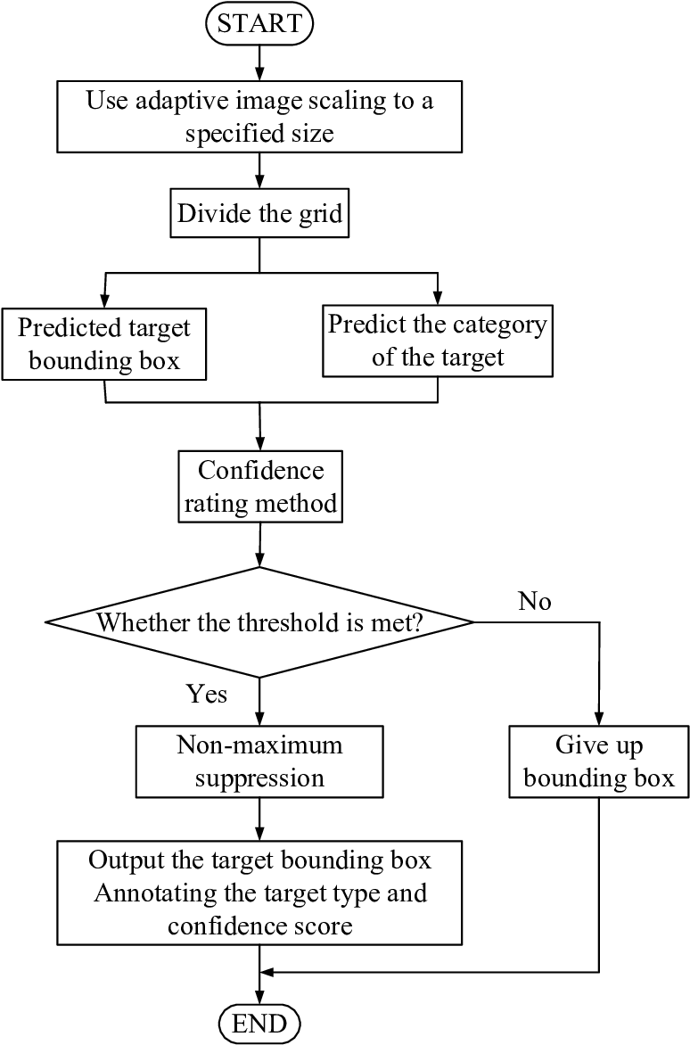

**Training YOLO for Number Plate Detection:**

Dataset Preparation: Curating a comprehensive dataset containing images and videos of two-wheelers with visible number plates. Annotations for these datasets would include bounding boxes around number plates, indicating their positions within the images or frames.

Model Configuration: Configuring the YOLO model architecture (e.g., YOLOv3 or YOLOv4) for the specific task of number plate detection. Fine-tuning the model's architecture and hyperparameters based on the dataset characteristics and performance requirements.

Training and Optimization: Training the YOLO model using the prepared dataset to recognize and localize number plates accurately. Iterative training processes, adjusting parameters, and optimizing the model to achieve high precision and recall for number plate detection.

**Integration for Real-Time Processing:**

Model Integration: Incorporating the trained YOLO model into the number plate system architecture, enabling seamless interaction and information exchange with other components like vehicle detection and penalty generation modules.

Video Stream Processing: Implementing mechanisms to feed live video streams from surveillance cameras or sources into the YOLO model for continuous real-time object detection. Processing each frame to detect and locate number plates on two-wheelers within the video feed.

**Challan Generation and Enforcement:**

Number Plate Recognition: Upon successful detection of number plates by YOLO, extracting the recognized plate information from the bounding boxes' coordinates.

Violation Detection: Utilizing the extracted number plate information to cross-reference against databases or predefined rules to detect violations, such as the absence of helmets or exceeding occupancy limits (triple seating).

Automated Penalty Generation: Integrating the violation detection results with the challan generation system. Automatically generating challans or penalty notices for detected violations, including information extracted from number plates, violation type, and other relevant data.

Enforcement Workflow: Designing an efficient workflow to ensure accurate penalty issuance based on violation evidence captured by YOLO, streamlining the enforcement process and facilitating prompt action against non-compliant behaviors.

**System Optimization and Deployment:**

Optimizing Performance: Fine-tuning the YOLO model and the overall system for optimal performance, reducing false positives and negatives to enhance accuracy in violation detection and challan generation.

Deployment Considerations: Ensuring the deployed system, equipped with YOLO-based number plate recognition and penalty generation capabilities, is scalable, resource-efficient, and compatible with the deployment environment, whether on edge devices or centralized servers.

In essence, integrating YOLO into our system involves training, integration, real-time object detection, and automated violation detection and challan generation processes. This comprehensive integration enables efficient enforcement of traffic regulations, leveraging YOLO's capabilities for accurate number plate detection and subsequent penalty generation.

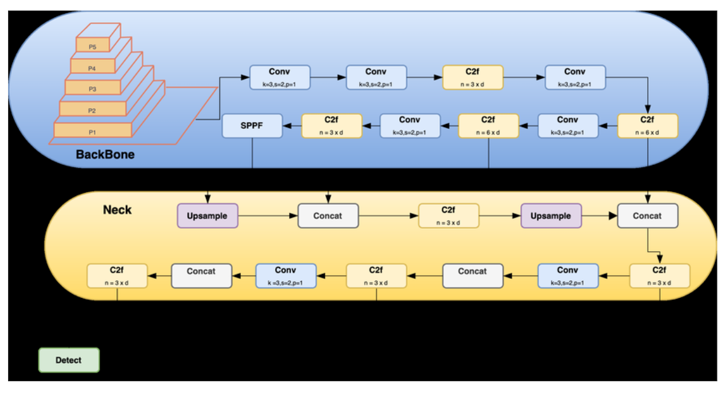

*Fig 2: Architecture of YOLO v8*

1. **ROI MODEL (Region of Interest)**

Utilizing a Region of Interest (ROI) model within the system for chalan generation involves a strategic approach to detect and process specific areas within images or frames, focusing on the region containing number plates. Here's a detailed breakdown of how an ROI-based model can be integrated into the workflow:

**ROI Model Training for Number Plate Detection:**

1. Dataset Preparation: Curating a dataset comprising images or video frames focusing on two-wheeler regions, particularly emphasizing the area where number plates are typically located. This dataset should include annotated regions indicating the location and boundaries of number plates.

2. Model Configuration: Configuring a deep learning model, such as a convolutional neural network (CNN) or a specific architecture like Faster R-CNN or SSD, to serve as the ROI-based number plate detection model. The model should be tailored to recognize and extract number plates from within the specified regions.

3. Training and Optimization: Training the ROI model using the prepared dataset, emphasizing the accurate identification and localization of number plates within the defined regions of interest. Iteratively optimizing the model's parameters to achieve high precision and recall for number plate detection.

**Integration into Numberplate System for Chalan Generation:**

1. Region-based Processing: Implementing mechanisms within the NumberPlate system to feed images or frames into the ROI model for region-specific processing. The model focuses on extracting regions of interest, i.e., number plates, from the input images or video frames.

2. Number Plate Recognition: Utilizing the output of the ROI model to extract and identify number plates accurately. This information includes the recognized text or patterns from the detected number plates within the defined regions.

**Chalan Generation and Enforcement:**

1. Violation Detection: Utilizing the extracted number plate information to cross-reference against databases or predefined rules to detect violations, such as non-compliance with helmet regulations or exceeding occupancy limits.

2.Automated Penalty Generation: Integrating the violation detection results with the chalan generation system. Automatically generating chalans or penalty notices based on the information extracted from the recognized number plates and the detected violations.

3. Enforcement Workflow: Designing an efficient workflow that facilitates the accurate issuance of penalties based on the violation evidence captured by the ROI model. This ensures that the system takes prompt and accurate actions against non-compliant behaviors.

**System Optimization and Deployment:**

1.Optimizing Performance**:** Fine-tuning the ROI model and the overall system to improve accuracy, minimize false detections, and enhance the precision of the number plate extraction process.

2. Deployment Considerations: Ensuring the deployed system, equipped with the ROI-based number plate recognition and penalty generation capabilities, is scalable, efficient, and adaptable to the deployment environment, whether on edge devices or centralized servers.

In summary, integrating an ROI-based model into the system involves training, integration, region-specific processing for number plate detection, and subsequent automated violation detection and chalan generation processes. This integration ensures targeted and accurate identification of number plates within specific regions of interest, facilitating efficient enforcement of traffic regulations.

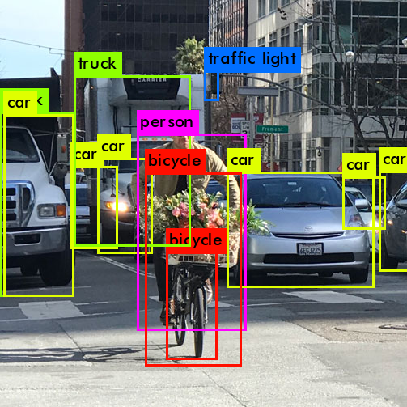

*Fig 3 : ROI model selecting only the region of interest*

**CHAPTER 3 : DETAILS**

**3.1 WORK DONE**

Absolutely! Here's an outline of the working mechanism of the 'Helmet and Number Plate Detection for Challan Generation' project using steps:

**Data Collection:**

Gather a diverse dataset consisting of images or videos depicting riders with helmets, without helmets, riding triple seat, and various number plate orientations.

**Preprocessing**:

Clean and prepare the collected data, ensuring uniformity and quality for training purposes. This may involve resizing images, normalization, and data augmentation techniques.

**Loading YOLO from Ultralytics:**

Utilize the YOLO (You Only Look Once) object detection system from Ultralytics, a state-of-the-art deep learning framework renowned for its speed and accuracy in real-time object detection tasks.

**Train Model 'n' Epochs:**

Use the collected and preprocessed dataset to train the YOLO model for 'n' epochs. During training, the model learns to identify and classify objects of interest such as riders, helmets, and number plates.

**Get the Best Model Weight:**

Evaluate the trained models based on their performance metrics (like precision, recall, and accuracy) using a validation set. Select the model with the best weights that demonstrate superior performance.

**Object Detection:**

Model Selection: Employed YOLOv8, a state-of-the-art real-time object detection model, for robust and efficient identification of objects within images and video frames.Custom Classes: Trained the YOLOv8 model to recognize custom classes specific to the project, including two-wheeler vehicles and other relevant objects.Real-time Processing: Achieved real-time object detection capabilities, enabling instantaneous analysis and identification of objects present in live video streams or static images.

**Helmet Detection:**

Utilization of Pre-trained Model: Integrated a pre-trained YOLOv8 model for helmet detection, leveraging transfer learning to adapt the model for the project's specific requirements.

Bounding Box Generation: Implemented the model to generate bounding boxes around detected helmets, providing a visual representation of identified safety gear.Safety Compliance: Enabled the system to assess whether individuals in the scene were complying with safety regulations by wearing helmets, contributing to enhanced safety monitoring.

**Number Plate Detection:**

YOLOv8 for Number Plates: Applied YOLOv8 to accurately detect and localize vehicle number plates within the images or video frames.Plate Recognizer Integration: Incorporated the Plate Recognizer API for Optical Character Recognition (OCR), extracting alphanumeric characters from the detected number plates.Challan Generation: Utilized the recognized number plate information for challan generation, facilitating an automated system for tracking and penalizing vehicles as needed.

**Model Evaluation:**

Assess the model's performance in detecting the specified objects accurately. Evaluate its precision, recall, and overall accuracy in correctly identifying helmets, number plates, and riders violating traffic laws.

1. **Login Window**



1. **Home Window**

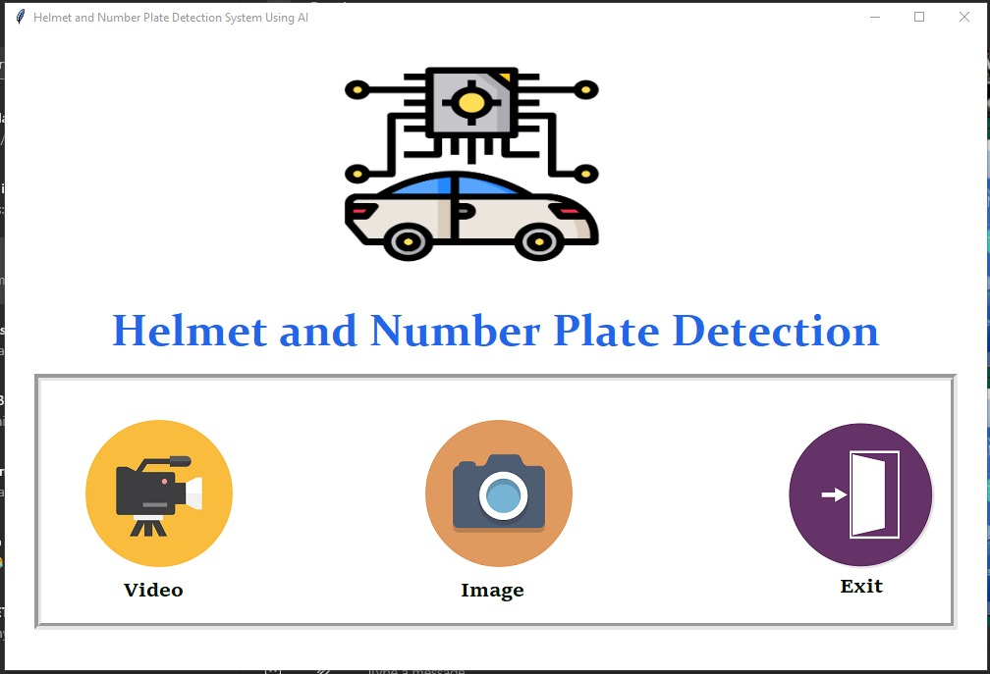

1. **Output Window**

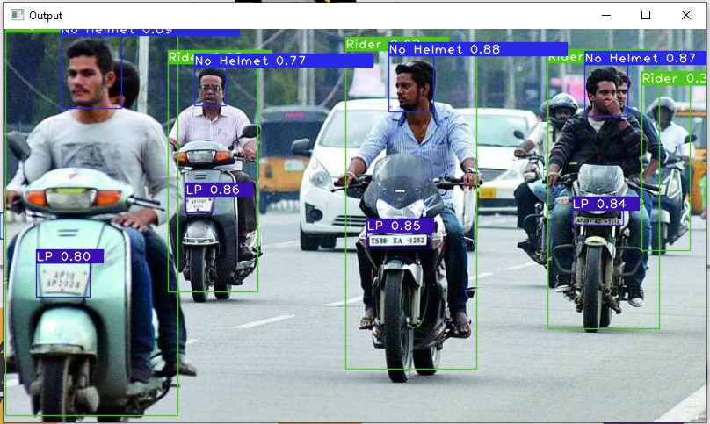

**3.2 SOFTWARE USED**

**3.2.1 Python**

Python is a high-level, interpreted programming language known for its readability and simplicity.

Created by Guido van Rossum and first released in 1991, Python has become one of the most popular programming languages.

Python supports multiple programming paradigms, including procedural, object-oriented, and functional programming.

It has a large standard library that includes modules and packages for various tasks, making it versatile for different applications.

**3.3 FUTURE ADVANCEMENTS**

**1. E-Challan Implementation:**

Building upon the successful algorithm for identifying traffic violations, the next phase involves the implementation of an e-challan system. This system will leverage the captured data to generate electronic challans for drivers found violating traffic rules. The integration of this system with the existing infrastructure aims to streamline the penalty process and ensure efficient enforcement. The development of an intuitive and automated e-challan generation mechanism will reduce manual intervention and enhance the speed and accuracy of penalty enforcement.

**2. Hardware Implementation:**

In tandem with software enhancements, the project will extend its focus to the hardware aspect. This involves the development and deployment of specialized hardware structures to augment the algorithm's capabilities. This hardware will encompass advanced cameras, sensors, and computing devices strategically positioned at traffic hotspots. These devices will collaborate with the algorithm to provide real-time data acquisition and processing, thereby strengthening the system's overall efficiency and accuracy in identifying violations. Additionally, considerations for the robustness, scalability, and cost-effectiveness of the hardware infrastructure will be prioritized to ensure seamless integration into existing traffic management frameworks.

**3. Integration and Testing:**

A pivotal phase involves the integration of the e-challan system with the algorithm and the hardware components. Rigorous testing protocols will be implemented to validate the system's performance under various traffic conditions and scenarios. Thorough testing will ensure the reliability and accuracy of the e-challan generation process and the seamless collaboration between software and hardware components

**CHAPTER 4 : RESULTS, DISCUSSIONS AND CONCLUSIONS**

**4.1 RESULT**

Till now, we have successfully engineered an advanced algorithm meticulously designed to swiftly and accurately recognize two-wheeler vehicles within real-time video feeds. Leveraging state-of-the-art machine learning techniques and image processing capabilities, this algorithm exhibits exceptional precision in identifying and isolating motorcycles, scooters, and other two-wheeled vehicles amidst varying traffic scenarios.

Moreover, the algorithm seamlessly integrates sophisticated pre-written code and object recognition models to discern whether riders are adhering to safety protocols by wearing helmets. Through an intricate analysis of visual cues and features within the video streams, it accurately distinguishes between helmeted and non-helmeted riders.

Its ability to swiftly and precisely identify both the vehicle type and the adherence to safety measures exemplifies a breakthrough in the application of machine learning for traffic regulation and safety enforcement.

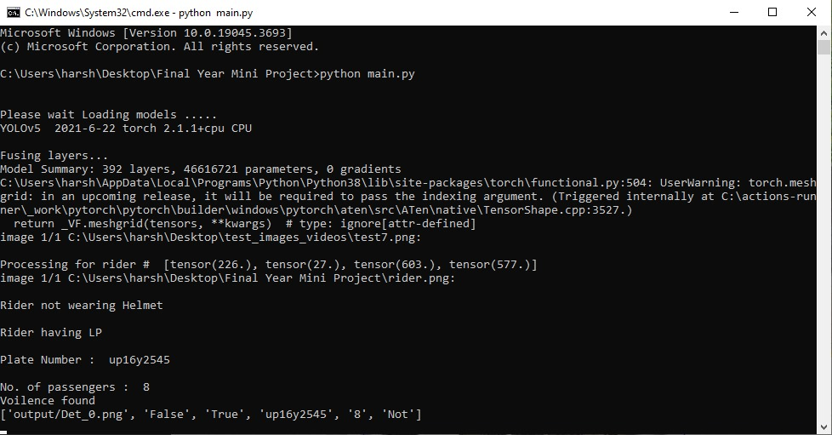

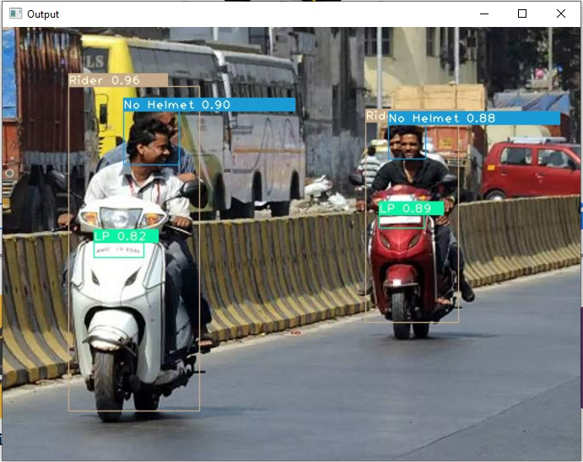

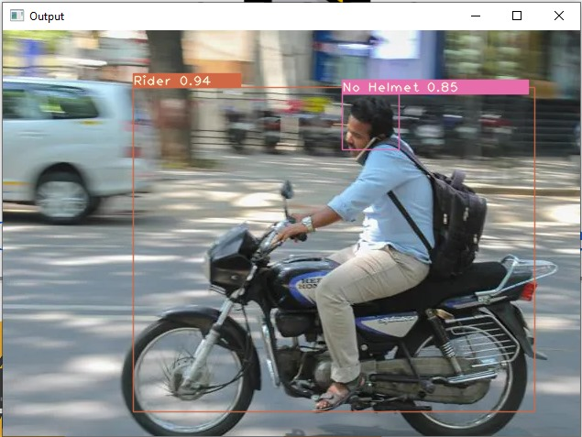

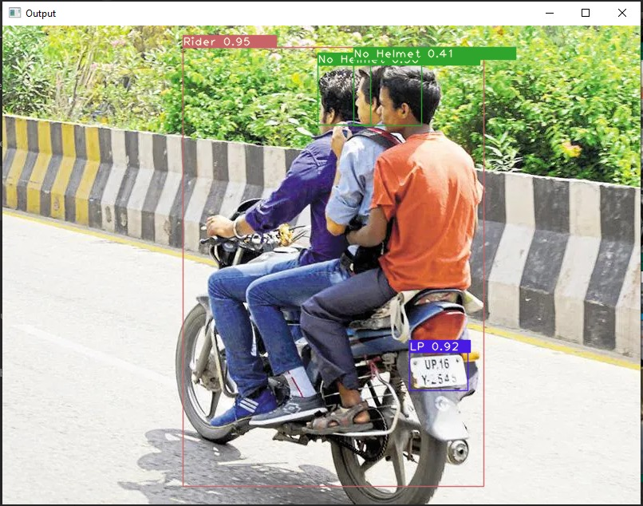

**4.2 MODEL EVALUATION**

**Accuracy:**

Definition: Measures the overall correctness of the model by calculating the ratio of correctly predicted instances to the total instances.

Formula: (True Positives + True Negatives) / (Total Predictions)

Good Value: Generally high accuracy is desired, but it may not be suitable for imbalanced datasets.

**Precision:**

Definition: Measures the accuracy of positive predictions, representing the proportion of true positives among instances predicted as positive.

Formula: True Positives / (True Positives + False Positives)

Good Value: Higher precision is desirable, indicating fewer false positives. Important in scenarios where false positives are costly.

**Recall (Sensitivity or True Positive Rate):**

Definition: Measures the model's ability to capture all relevant instances, representing the proportion of true positives among actual positive instances.

Formula: True Positives / (True Positives + False Negatives)

Good Value: Higher recall is desirable, especially in situations where missing positive instances is more critical than false positives.

**F1 Score:**

Definition: The harmonic mean of precision and recall, providing a balanced measure that considers both false positives and false negatives.

Formula: 2 * (Precision * Recall) / (Precision + Recall)

Good Value: High F1 score is desirable, indicating a good balance between precision and recall. Particularly useful when there is an uneven class distribution

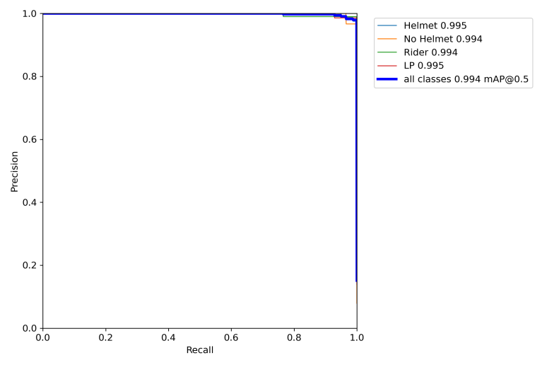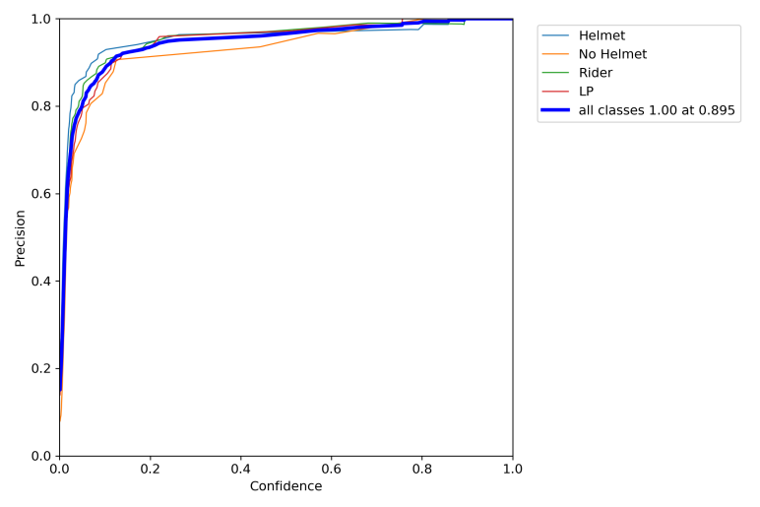

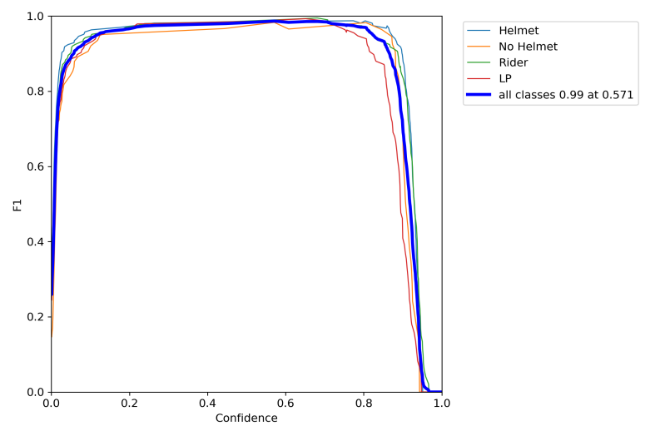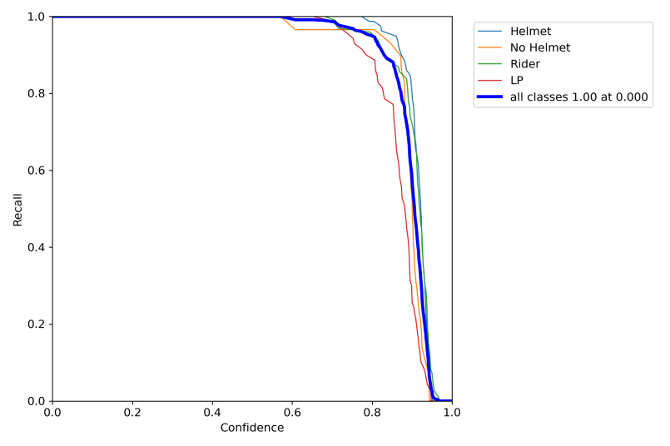

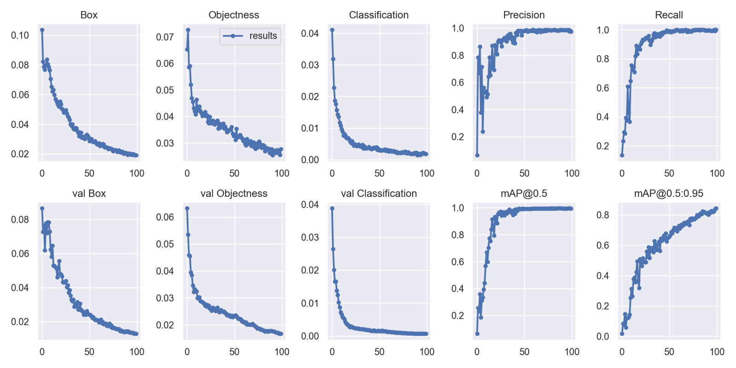

**4.3 CONCLUSIONS:**

Hence, we have implemented an algorithm that adeptly identifies two-wheeler vehicles within real-time video feeds, demonstrating exceptional accuracy and swiftness in this recognition process. Moreover, our implementation ensures precise determination of riders' adherence to safety regulations by effectively detecting whether helmets are being worn.

This implementation stands as a testament to the efficacy of our approach, leveraging cutting-edge machine learning and image processing techniques. The successful integration of these technologies has enabled us to achieve a milestone in traffic safety, setting a new standard for automated identification of safety violations.

Consequently, this implementation lays a strong foundation for future advancements in automated enforcement mechanisms and proactive safety measures. Its accuracy and reliability underscore its potential to revolutionize traffic regulation strategies, fostering a safer and more regulated traffic environment.

In summary, this implementation not only showcases technological excellence but also signifies a crucial step towards promoting a culture of compliance with safety norms, emphasizing the pivotal role of innovation in shaping a responsible and secure traffic landscape.

**CHAPTER 5 :** **LITERATURE CITED**

1. <https://pjreddie.com/darknet/yolo/>
2. <https://github.com/pjreddie/darknet/blob/master/data/coco.names>
3. <https://docs.opencv.org/4.x/>
4. <https://www.researchgate.net/publication/351411017_RealTime_Object_Detection_Using_YOLO_A_Review>
5. <https://github.com/HumanSignal/labelImg>
6. <https://valueml.com/helmet-detection-using-tensorflow-and-keras/>
7. <https://tiwarinitin1999.medium.com/yolov3-custom-object-detection-with-transfer-learning-47186c8f166d>
8. Investigation regarding the Performance of YOLOv8 in Pedestrian Detection:- https://www.diva-portal.org/smash/get/diva2:1778368/FULLTEXT01.pdf
9. https://github.com/TheSiddheshFulawade/Helmet-Detection-and-Number-Plate-Recognition-Using-YOLO
10. A Robust Real-Time Automatic License Plate Recognition Based on the YOLO Detector:-https://arxiv.org/abs/1802.09567
11. Number Plate Detection Using Yolo & Text Extraction Using Ocr:-https://www.jetir.org/papers/JETIR2303771.pdf
12. Real-time Helmet Detection with YOLO(Authors: Goyal, A., et al. (2021)):- https://arxiv.org/abs/2304.08256
13. YOLO-Based Object Detection and Tracking Framework for Smart Traffic Monitoring:-https://ieeexplore.ieee.org/document/9544598
14. a Comprehensive Review Of Yolo: From Yolov1 And Beyond:- https://arxiv.org/pdf/2304.00501.pdf
15. Object Detection with Deep Learning: A Review:- https://arxiv.org/pdf/1807.05511.pdf